Website Feedback
- Preferred theme – Carbon – Centred Header- Sticky Hero – Split Intro
- Logo to be slightly larger on the welcome page and slightly smaller on the remaining pages, while still being larger than the current size.
- Use the full-colour logo on the welcome page and a black-and-white version on all other pages.
- Menu items needs more visibility (Use a larger font size, with a thin white line to clearly separate or demarcate the menu area)
- Can we change the layout of the Our Work and Current Work sections. We are not fond of square display option. Can we think of something else? An asymmetric layout.
- Remove the our store section
- Contact us/Free Quote form to contain following
  - Name
  - Email*
  - Phone*
  - Suburb*
  - Budget ($10,000 - $25,000, $25,000 - $50,000, $50,000 - $75,000, $75,000 - $100,000, >$100,000)*
  - Description
- Remove walkways
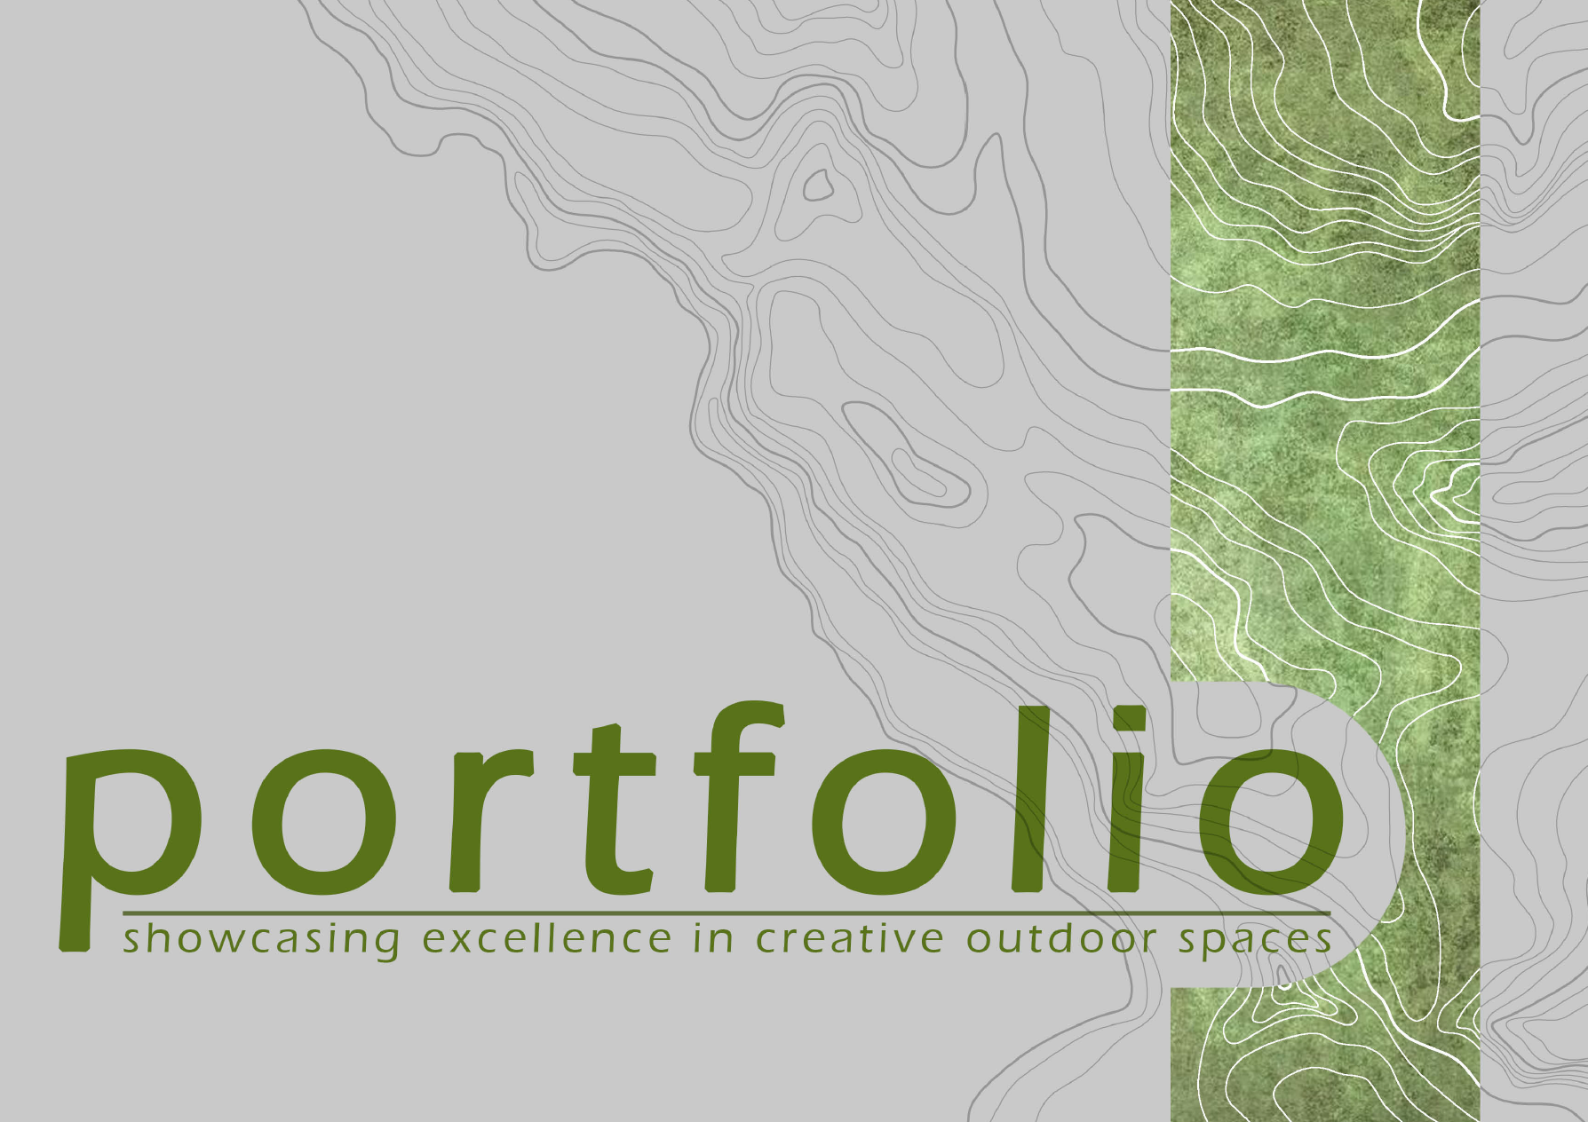
- Use subtle, light contour-style lines in the background of the dark-coloured sections only. Do not use the contour lines in the opening/start section.

- Portfolio presentation – use a layout similar to the reference below, but avoid rectangular shapes. Follow the curved design concept throughout for a softer, more consistent look.

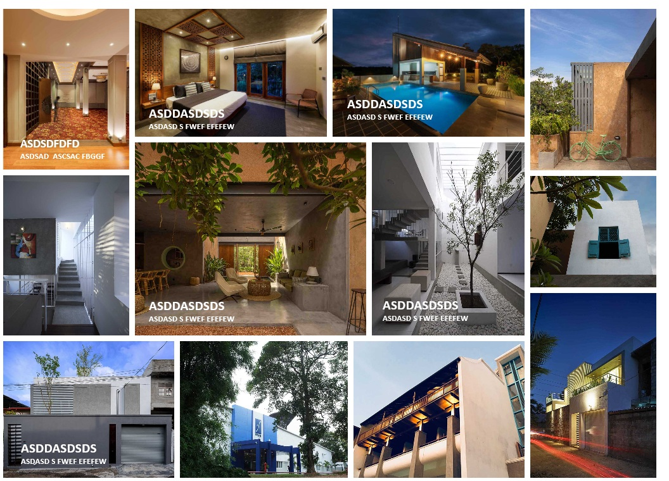

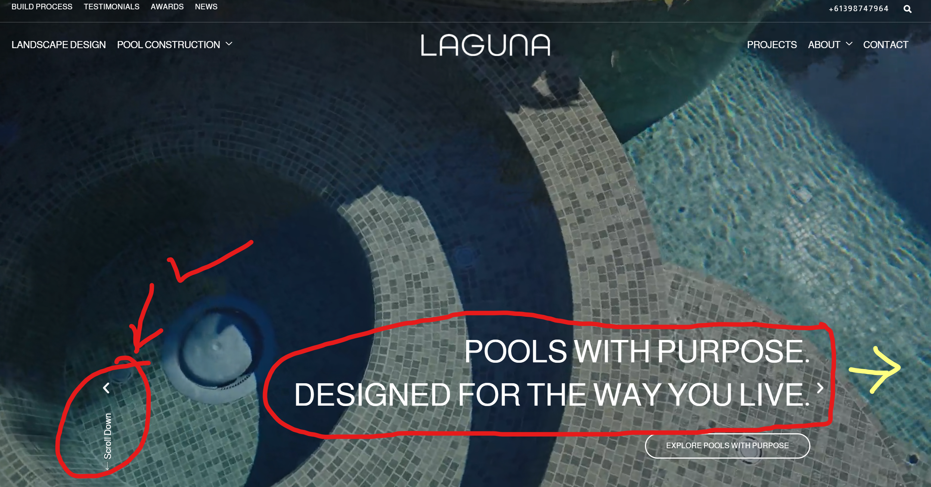

Welcome notes need to align to the right side and reduce the font size.
Scroll down – add arrow head and keep same animation.

- A floating button for Get a Free Quote
- An option to download documents in each services section
- Our process section to contain images instead of icons and a page containing more details.
- 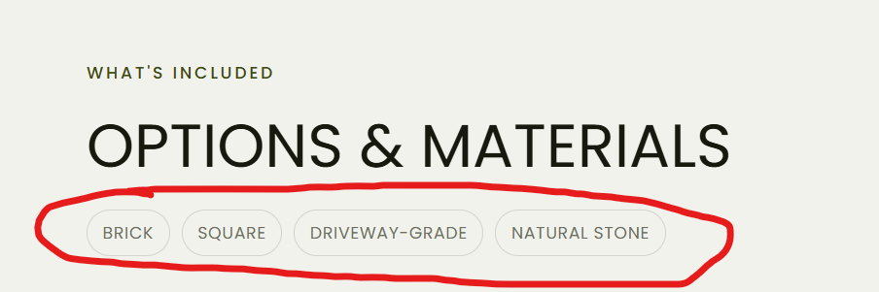
Follow this method;
Brick | Square | Driveway-grade | Natural stone

